**Exercise1**.

Create a Customer Registration form. Form contains an Add button. When user click on add button a Table will display just below form to display added customer.

Form fields are:

* Customer ID (Auto generate & read only)
* Name
* Address (text area)
* Mobile
* Fax
* Email
* Action (Contains Delete button)

Name, Mobile & Email are compulsory fields.

When user click on delete button particular record should be deleted from table.

**Exercise2**.

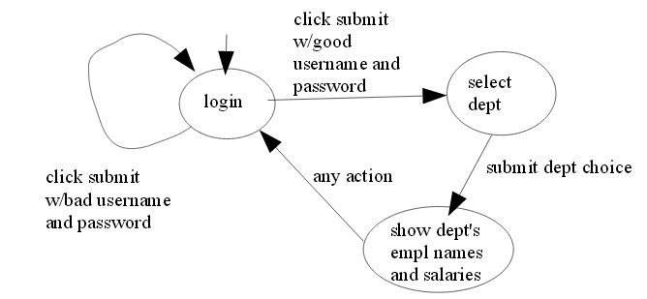

**Exercise3.**

Create a User Registration Form-

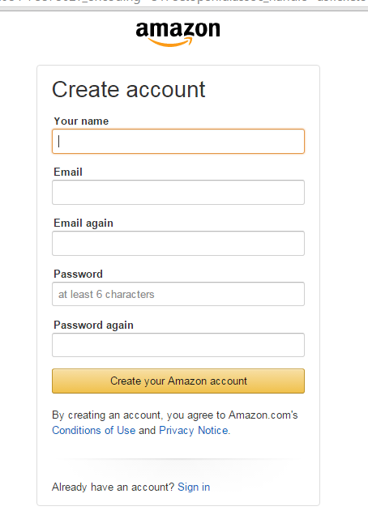

If Email Id is not registered then start User session

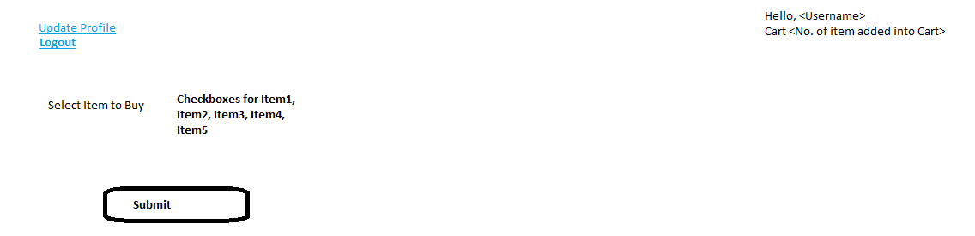

When user click on Update Profile, User can able to edit his/her profile

No. of items user can select & click submit to purchase it. Whenever any checkbox selected / unselected Cart value should be refresh.

Once user click on submit, items selected should be get purchased

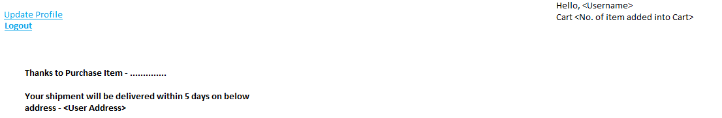

User can Logout system by clicking on Logout button.